CPE 435: OPERATING SYSTEMS LABORATORY.

**Lab 13.**

**Docker Containers.**

**Submitted by**: Dan Otieno.

**Date of Experiment**: 04/14/23.

**Report Deadline**: 04/23/23

**Demonstration Deadline**: 04/21/23.

# **Introduction:**

The goal for this lab was to learn how Dockers works. Dockers are a type of containers that provide the functionalities to help create and deploy applications.

# **Lab Assignment:**

* Log into the echo server, and then log into your assigned odroid as an odroid user. The first thing we are going to do is verify if you have sudo user access. Inorder to verify you have sudo user access, please perform the following command. You will use the sudo

command followed by -v.

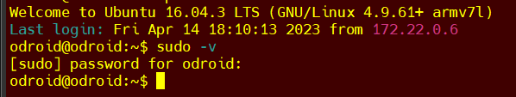

Although we have not installed docker on our machine, let us verify one last time. Please type docker in your terminal. You should see a command not found or something of that sort.

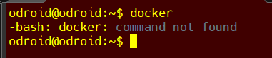

**Assignment 1****: Installation of Docker on ARM machine.**

The machine that we are using is odroid, which is an ARM machine. You can type cat/proc/cpuinfo to see the processor information of the machine that you are using. We also need to find out the OS version that we are using. Please use the following commands and answer the questions that follow, make sure to include a supporting screenshot for each of the questions.

* lsb_release -a
* uname -a

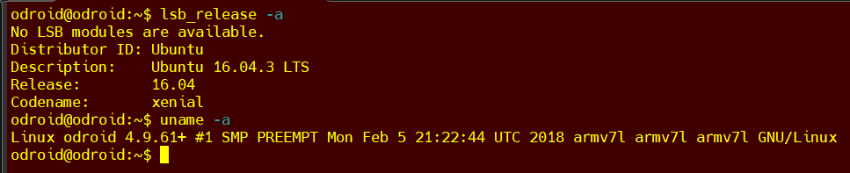

* + What is the OS name and version in your machine? **Ubuntu** version **16.04.3.**
  + What is the kernel version in your machine? **4.9.61+.**
  + How many processors are there in your machine and what are their model names? **ARMv7 Processor rev 3. (8 processors).**

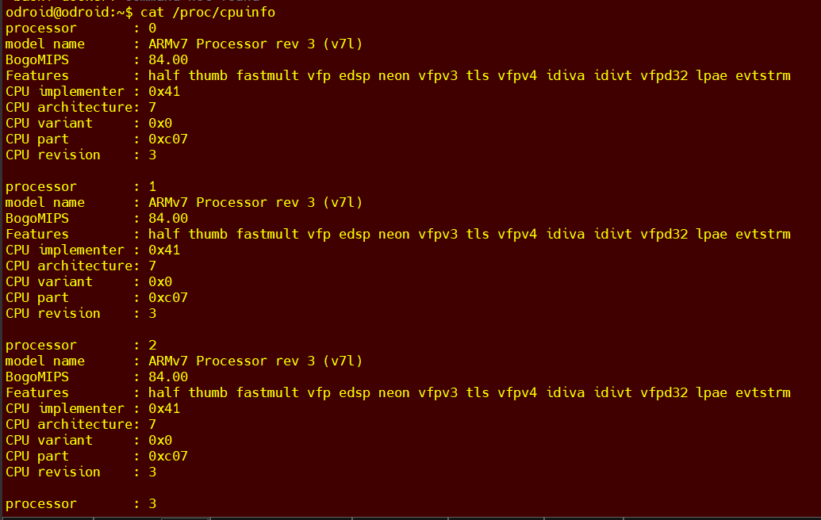

We need to remove docker, if there is any, before moving forward. So, please do the following in your terminal.

Please follow as it shows in the image below:

sudo apt-get remove docker docker-engine docker.io containerd runc docker-ce

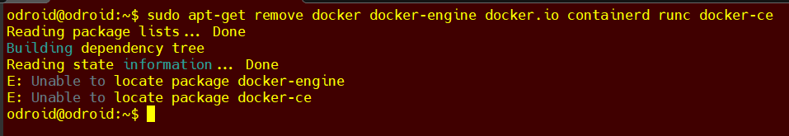

Now, let us update.

sudo apt-get update

You might see some warnings, but ignore them for now. Let us move forward with some installations.

sudo apt-get install apt-transport-https ca-certificates curl gnupg-agent software-properties common

This will take some time to complete, but there should be no problem to install. If asked to continue, select Y for yes and continue.

Before we can add docker's official GPG key we will need to update the DNS server used by the odroid if it has not been updated already. You can edit the DNS server to use UAH's current DNS server by modifying /etc/resolv.conf to use 146.229.1.200 and 146.229.56.2. However this change is not permanent, resetting the Odriod will undone this change. Alternatively you may use Google’s public DNS server (8.8.8.8 and 8.8.4.4) if necessary.

Edit the DNS server with the following:

sudo nano /etc/resolv.conf

Make the following change:

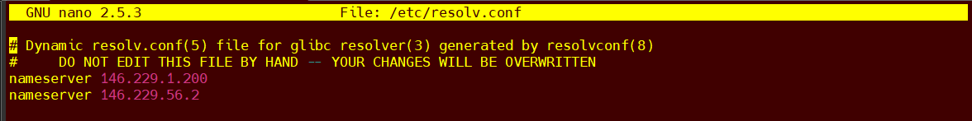

After this you should be able to add docker’s key:

curl -fsSL https://download.docker.com/linux/ubuntu/gpg | sudo apt-key add - , which should report you OK,



but we will verify that using the following command.

sudo apt-key fingerprint 0EBFCD88

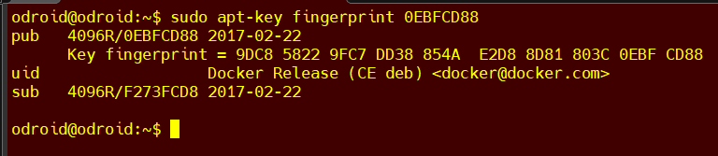

This should show you some installed keys.

Now is the main part where we will add the link to the repository of docker release based on our linux version and architecture of hardware we are using. Please use the following command:

sudo add-apt-repository "deb [arch=armhf] https://download.docker.com/linux/ubuntu $(lsb_release -cs) stable"

Now you have set up the repository. We will update once again, and install docker on our machine.

sudo apt-get update

sudo apt-get install docker-ce docker-ce-cli containerd.io

You might get similar messages while updating but you can ignore them again. Continue with the installation with the second command above. This will again take some time to complete.

**Assignment 2: Verify Docker Installation.**

Now that docker is installed properly, we have to verify installation. Please run the following:

sudo docker run hello-world

This will download an image and run it in a container. Please run this command, take a screenshot and read the contents of the output that you see.

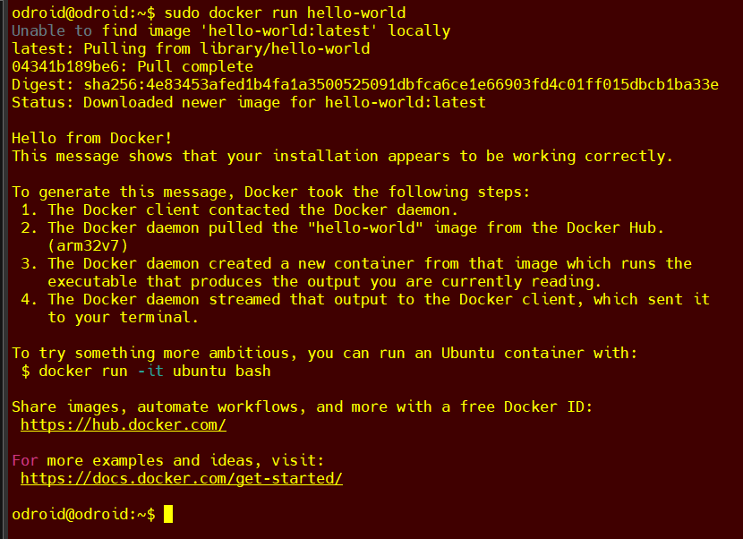

**Program and Dependency**

Following is the program that has some different dependencies.

|  |
| --- |
| # file: myPython2.py  import sys  def python2_stuff():  print("Yeah!!! This is function called only by python2.x")  print("This is an important function")  if sys.version_info[0]<3:  print("This will only work with python version 2.x")  python2_stuff()  else:  print("Error!!!You are not supposed to run it like this.") |

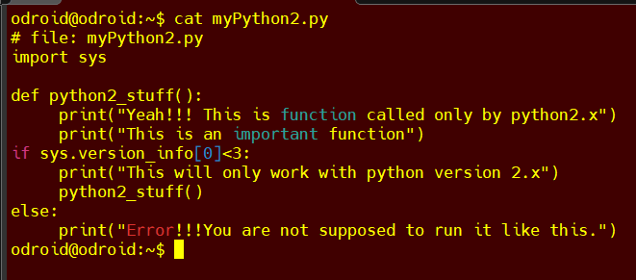

If you run this with python2, you will make a call to the function python2_stuff(). If you run with python3, the function will not be called. We want the function to be called because that is an important function. Please run this code using python2 myPython2.py. Take a screenshot of the output.

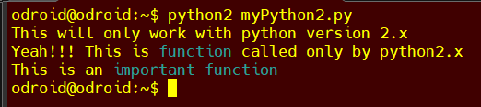

Let us remove python2 from our machine. Please use the following command to remove python 2.7. sudo apt purge python2.7-minimal

This will take some time and will remove python2.7. Now, try running the code again using python2. Do you notice any difference? Take a screenshot of the output.

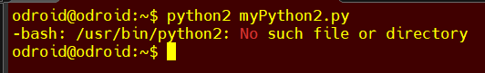

**Assignment 3: Running using a container.**

You only have python3 in your machine, but let us assume that the software that you wrote is in python2. You might be in a situation like this when you inherit a large software code base written in python2. Or in a different situation when you bought a software that is written in python2, but you are not allowed to install python2 on your machine due to company policy. The worst situation is when you do not know what dependencies are being used, or you do not want your customer to install dependencies and want to make things easier for them. A docker image can be created to manage and install any missing dependencies required while creating the image, and these dependencies are irrespective of what is installed in the machine.

Please run the following command a take a screenshot:

sudo docker run prawar/lab14_demo:public_student

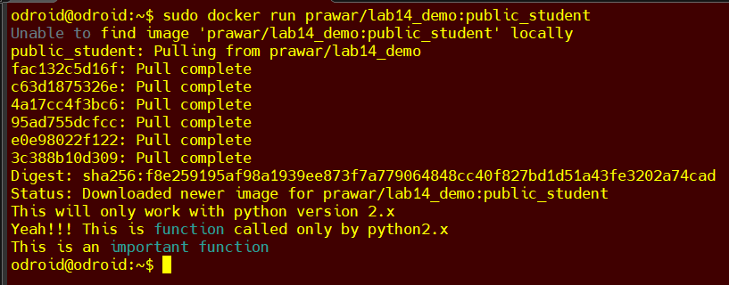

This will take some time to run. What docker run command does is it searches for the image by the name prawar/lab14_demo:public-student locally. If it does not find it in the local machine, as in our case, it downloads the image from docker hub and runs it. This is what it does for the first time you run it. Note that the output is the same as what you saw before you uninstalled python2.

If you run the command again, it will not download but instead it will run the local image. Please take a screenshot of this output.

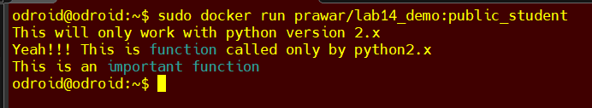

**Assignment 4: Creating Docker Image.**

For the assignment above, someone had already built an image and we ran it as a customer. But what if we are software developers and want to release a software but do not want customers to go through the hassle of installing all the dependencies? We have to create a docker image and release it to the public.

The docker image requires at least two files. One is called Dockerfile and the other is your source file. You can create other files based on your need, but we will create a minimal example for demonstration purposes. Dockerfile is the one that specifies all the commands a user will require to build an image. We will base our image on python2 so there is not much package installation that we need to do. But you can install other libraries and packages using the RUN instruction in the Dockerfile.

1. Create a new directory named myDocker.
2. Go inside the folder that you just created. This will be our directory for docker files that we need for our image.
3. Create a text file named Dockerfile and add the following contents in the file.



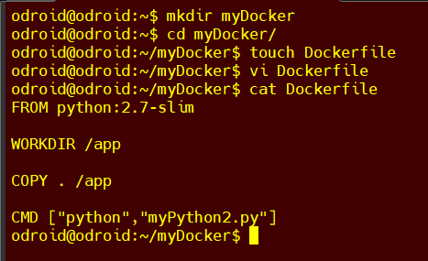

The commands in the file use python2.7 as the base for our image. it sets up /app as the working directory and copies the content of this current folder to /app.

1. Save the file.
2. The above file also mentions that the image should run python myPython2.py. Copy the code that runs for python2 from Assignment2 to the current folder (i.e. to the folder myDocker).
3. If your source file myPython2.py contains any other dependencies, you can install them using the RUN command in the Dockerfile.
4. Build the image using the following command sudo docker build --tag=mylab13_<yourchargerID> . .Replace yourchargerID with your charger id. Do not forget the '.' after a space after your charge id.

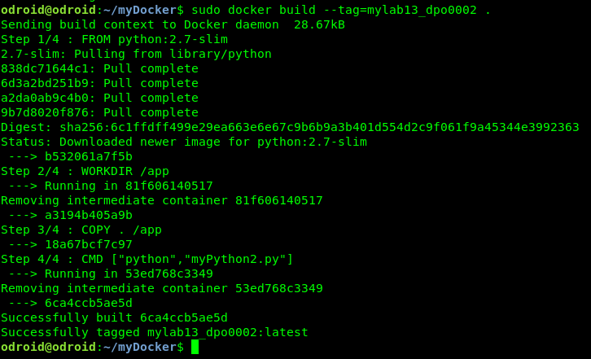

1. Perform docker image ls to see the images that are in your machine. You should see the image that you just created also. Take a screenshot.



1. Run the image that you just created using sudo docker run mylab13_<yourchargerID>. Take a screenshot

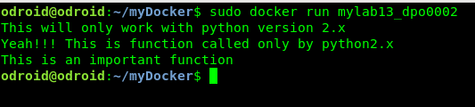

1. Go to hub.docker.com and create an account for you. After you have created an account, go to your working terminal and login using sudo docker login.

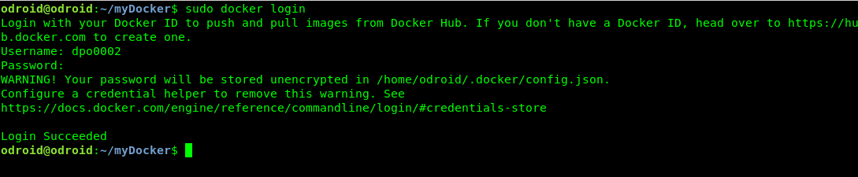

1. You will make this image available publicly, and download it again to run it in your machine. You need to tag it first. So what you will do is tag your repository using sudo docker tag mylab13_<yourchargerID> <yourusernameindockerhub>/lab13_public:<yourchargerID>.
2. Perform sudo docker image ls to see all the local repositories that you have. Take a screenshot. You should see a new one with the new tag. For the image that you created, what are the following values?
   1. Image name – **dpo0002/lab13_public**.
   2. TAG – **dpo0002**.
   3. image id – **6ca4ccb5ae5d**.
   4. size – **107MB**.

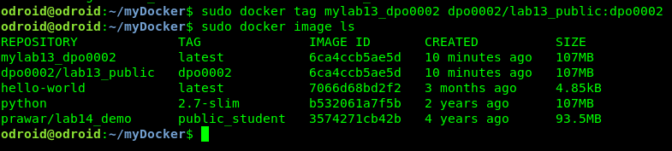

1. Push this image to the docker hub using sudo docker push <yourusernameindockerhub>/lab13_public:<yourchargerID>. After this operation is completed, go to your account in the docker hub and verify that it is available there. Take a screenshot.

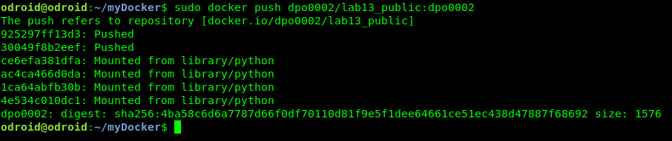

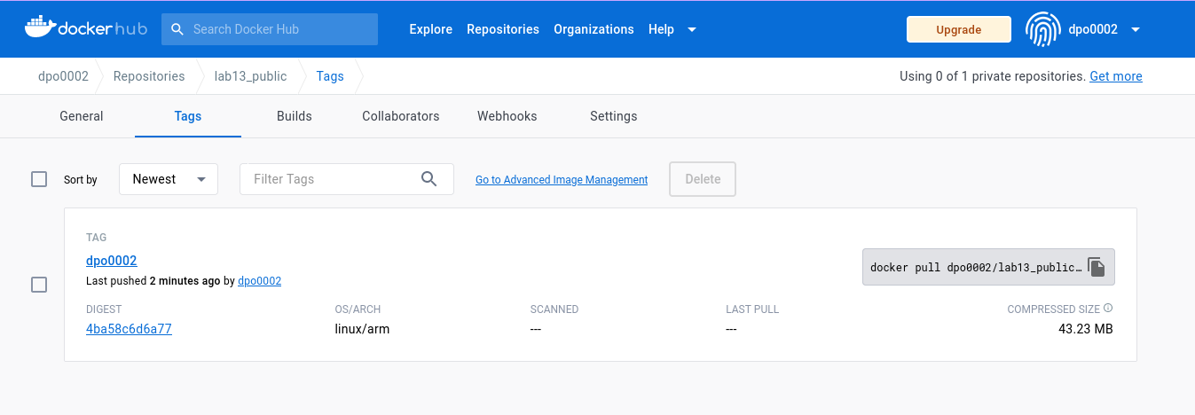

**Assignment 5: Distribution**.

Now that you have created a software that runs regardless of the dependencies available in the user machine, you would want to distribute it. Find at least one customer of your software (you can find a friend in CPE435) and tell them to download the image as you did in Assignment 3. Ask for a screenshot from them of the final run and post it in your report.

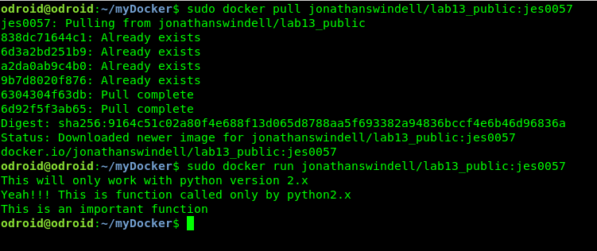

* For this assignment, Jonathan downloaded my image, and I downloaded his image, a screenshot of him pulling my docker image should be in his report.